Name : Saurabh Sanjay Jadhav

Topic : Dockerfile-2

Assignment no : 10

1. Install docker
2. Create dockerfile and ad the instructions in it.

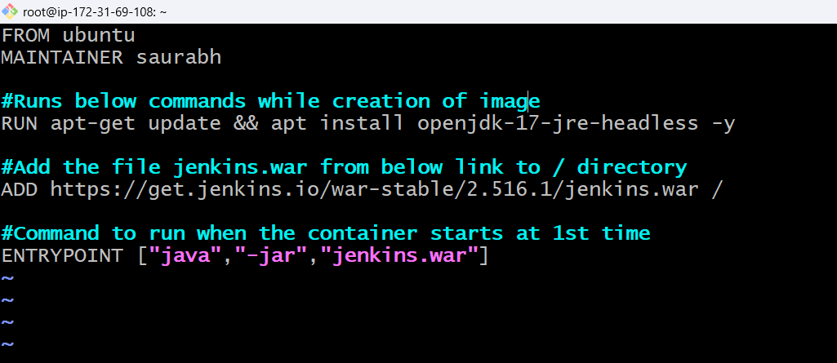

1. Build the docker image

Docker build -t Saurabhsj2711/Jenkins-1 .

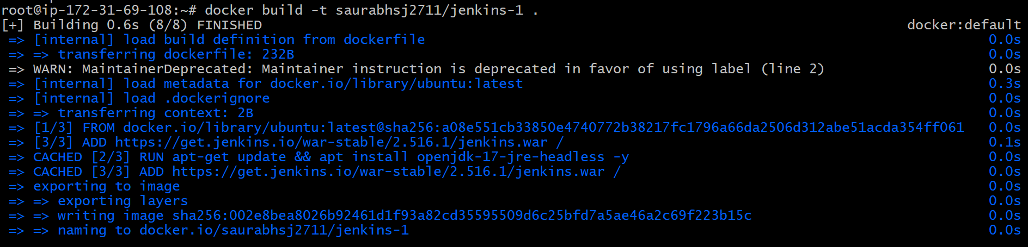

1. Run the docker container. Hence Jenkins get installed after starting the container.

Docker run –name ubuntu-jenkins-1 -it saurabhsj2711/Jenkins

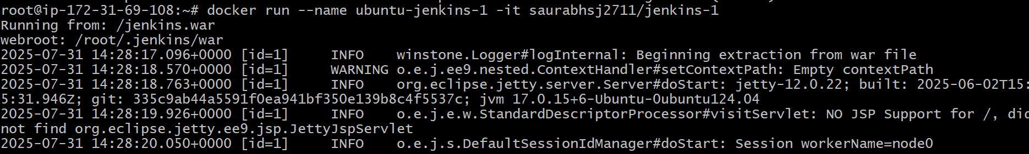



1. Successfully logged in to dockerhub account

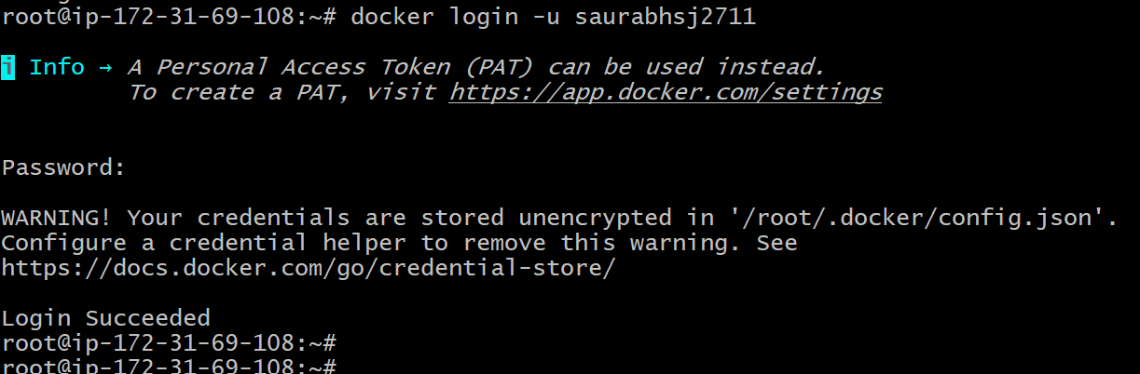

1. Pushed the image to dockerhub

Docker push <image-name>

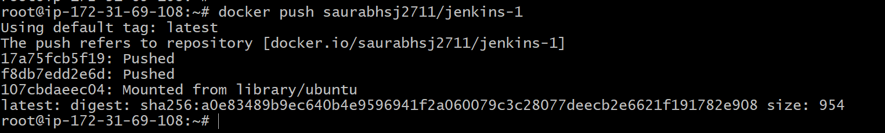

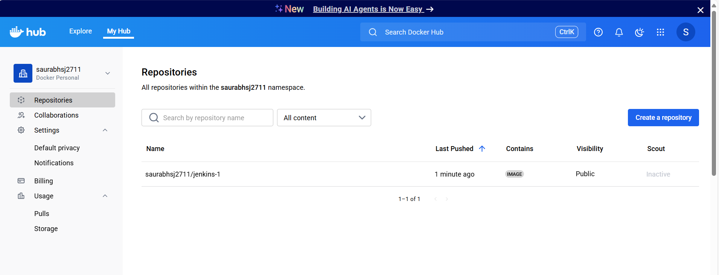

1. Create new dockerfile for copy and default dir.

When container starts it will be in working directory mentioned ‘/opt’.

File will be copied from from host instance to container default directory

Open the port 80 for accessing the container

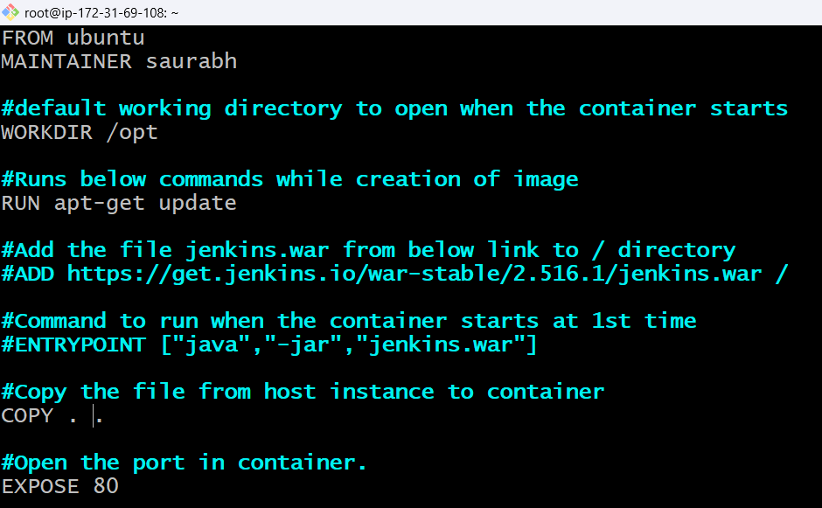

1. Successfully able to run the container.

